
National Textile University
Department of Computer Science
Subject:
Mobile Application Development
Submitted To:
Sir Rehan Sarwar
Submitted By:
Alishba Riasat
Registration No:
23-NTU-CS-1135
Lab No:
09
Semester:
6th

Task 1:
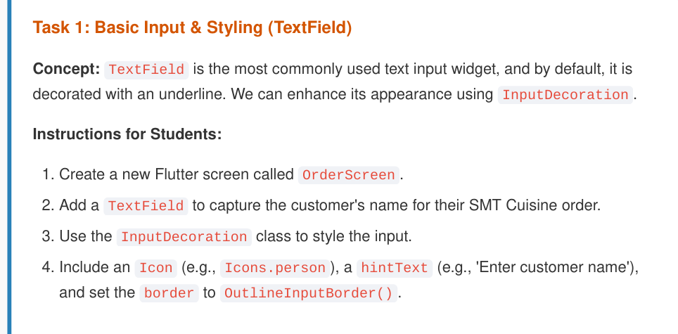

Code:
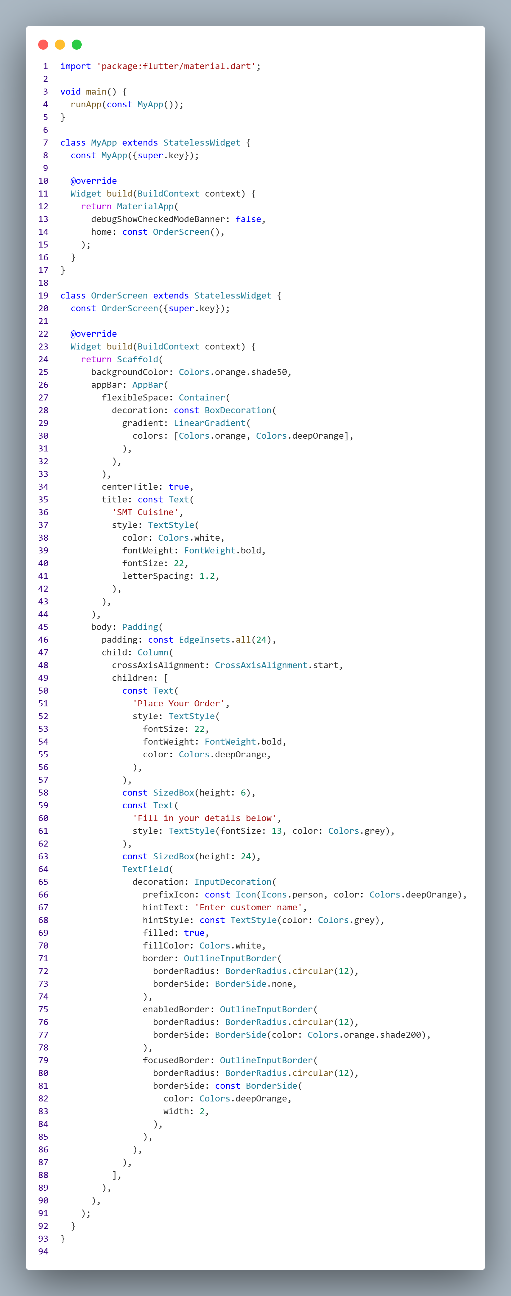
Output:
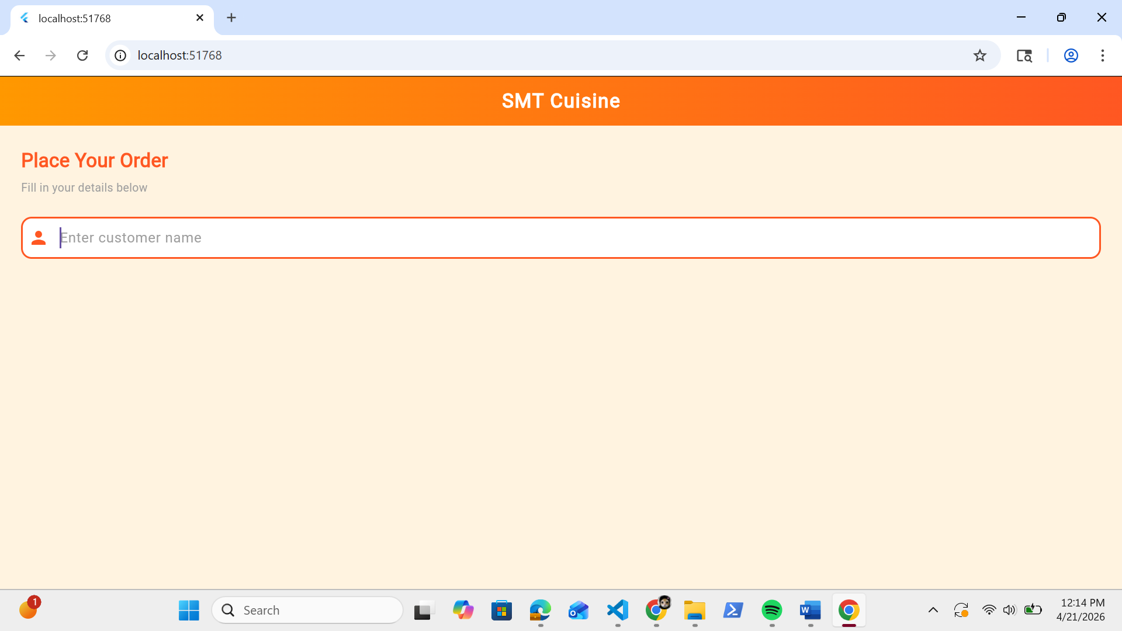

Task 2:
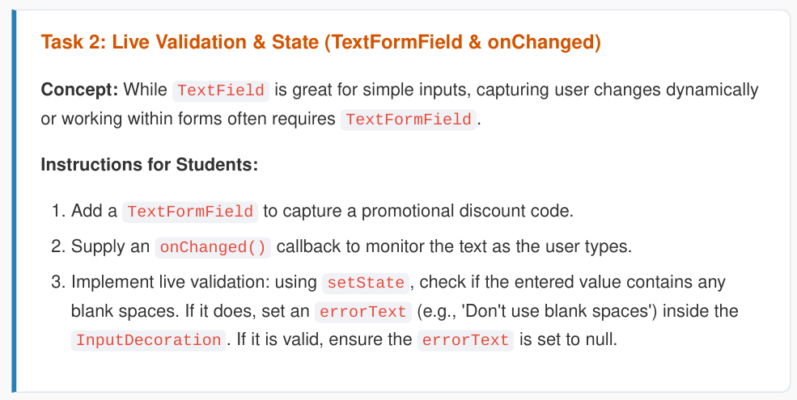

Code:
import 'package:flutter/material.dart';

void main() {
runApp(const MyApp());
}

class MyApp extends StatelessWidget {
const MyApp({super.key});

@override
Widget build(BuildContext context) {
return MaterialApp(
debugShowCheckedModeBanner: false,
home: const OrderScreen(),
);
}
}

class OrderScreen extends StatefulWidget {
const OrderScreen({super.key});

@override
State<OrderScreen> createState() => _OrderScreenState();
}

class _OrderScreenState extends State<OrderScreen> {
String? _discountError;

@override
Widget build(BuildContext context) {
return Scaffold(
backgroundColor: Colors.orange.shade50,
appBar: AppBar(
flexibleSpace: Container(
decoration: const BoxDecoration(
gradient: LinearGradient(
colors: [Colors.orange, Colors.deepOrange],
),
),
),
centerTitle: true,
title: const Text(
'SMT Cuisine',
style: TextStyle(
color: Colors.white,
fontWeight: FontWeight.bold,
fontSize: 22,
letterSpacing: 1.2,
),
),
),
body: Padding(
padding: const EdgeInsets.all(24),
child: Column(
crossAxisAlignment: CrossAxisAlignment.start,
children: [
const Text(
'Place Your Order',
style: TextStyle(
fontSize: 22,
fontWeight: FontWeight.bold,
color: Colors.deepOrange,
),
),
const SizedBox(height: 6),
const Text(
'Fill in your details below',
style: TextStyle(fontSize: 13, color: Colors.grey),
),
const SizedBox(height: 24),
TextField(
decoration: InputDecoration(
prefixIcon: const Icon(Icons.person, color: Colors.deepOrange),
hintText: 'Enter customer name',
hintStyle: const TextStyle(color: Colors.grey),
filled: true,
fillColor: Colors.white,
border: OutlineInputBorder(
borderRadius: BorderRadius.circular(12),
borderSide: BorderSide.none,
),
enabledBorder: OutlineInputBorder(
borderRadius: BorderRadius.circular(12),
borderSide: BorderSide(color: Colors.orange.shade200),
),
focusedBorder: OutlineInputBorder(
borderRadius: BorderRadius.circular(12),
borderSide: const BorderSide(
color: Colors.deepOrange,
width: 2,
),
),
),
),
const SizedBox(height: 16),
TextFormField(
decoration: InputDecoration(
prefixIcon: const Icon(Icons.discount, color: Colors.deepOrange),
hintText: 'Enter discount code',
hintStyle: const TextStyle(color: Colors.grey),
errorText: _discountError,
filled: true,
fillColor: Colors.white,
border: OutlineInputBorder(
borderRadius: BorderRadius.circular(12),
borderSide: BorderSide.none,
),
enabledBorder: OutlineInputBorder(
borderRadius: BorderRadius.circular(12),
borderSide: BorderSide(color: Colors.orange.shade200),
),
focusedBorder: OutlineInputBorder(
borderRadius: BorderRadius.circular(12),
borderSide: const BorderSide(
color: Colors.deepOrange,
width: 2,
),
),
),
onChanged: (value) {
setState(() {
if (value.contains(' ')) {
_discountError = "Don't use blank spaces";
} else {
_discountError = null;
}
});
},
),
],
),
),
);
}
}

Output:
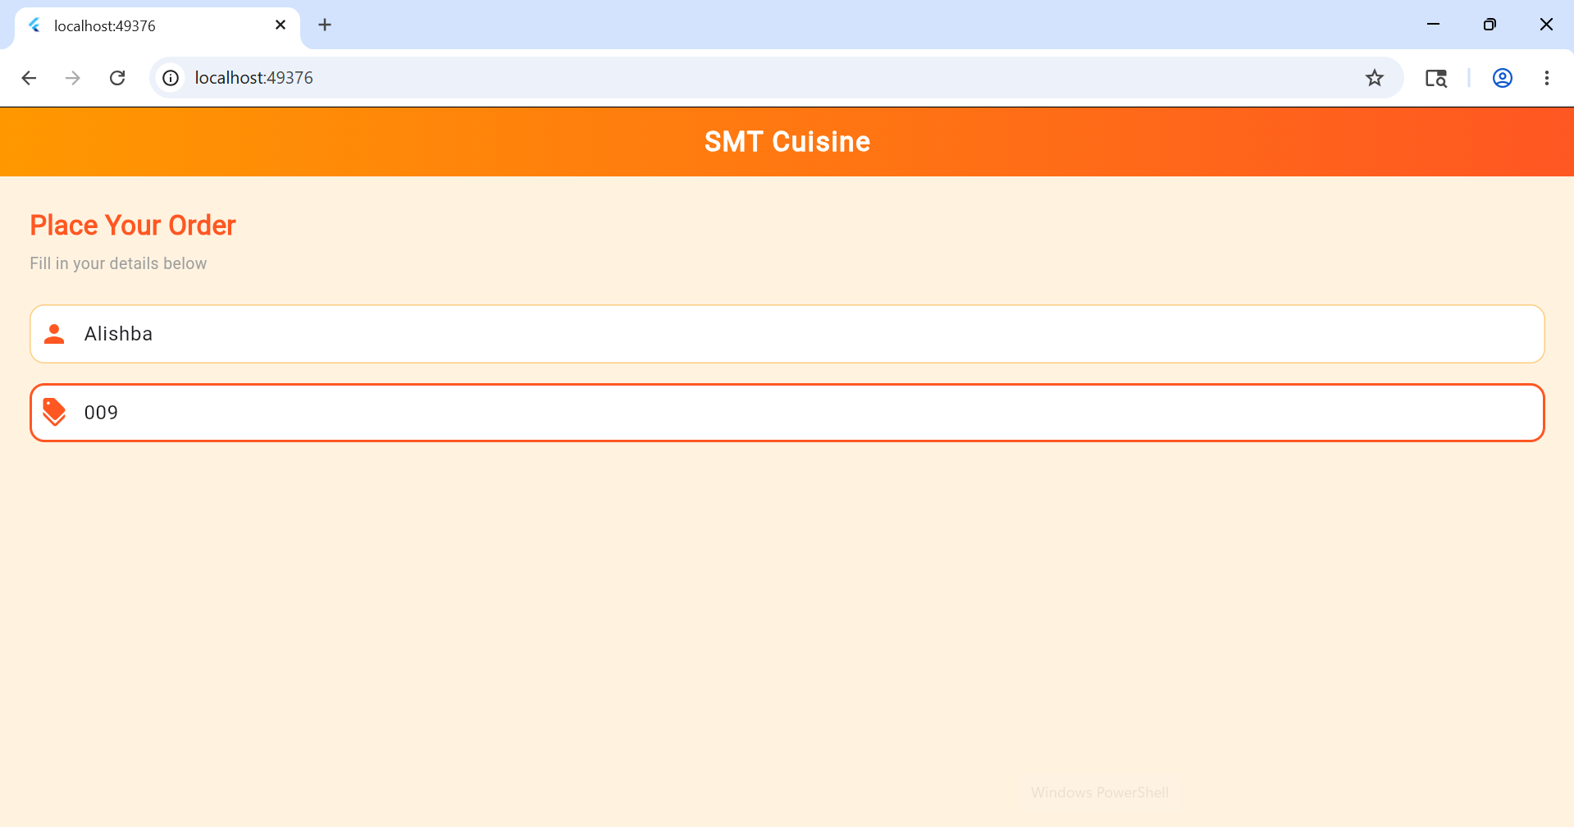

Task 3:

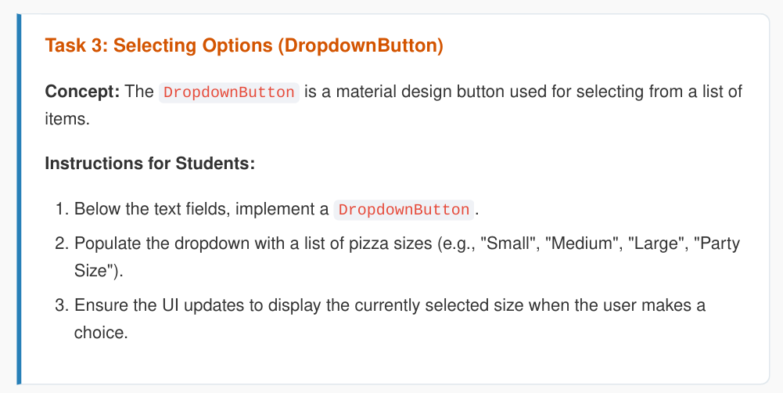
Code:
import 'package:flutter/material.dart';

void main() {
runApp(const MyApp());
}

class MyApp extends StatelessWidget {
const MyApp({super.key});

@override
Widget build(BuildContext context) {
return MaterialApp(
debugShowCheckedModeBanner: false,
home: const OrderScreen(),
);
}
}

class OrderScreen extends StatefulWidget {
const OrderScreen({super.key});

@override
State<OrderScreen> createState() => _OrderScreenState();
}

class _OrderScreenState extends State<OrderScreen> {
String? _discountError;
String _selectedSize = 'Medium';

final List<String> _pizzaSizes = ['Small', 'Medium', 'Large', 'Party Size'];

@override
Widget build(BuildContext context) {
return Scaffold(
backgroundColor: Colors.orange.shade50,
appBar: AppBar(
flexibleSpace: Container(
decoration: const BoxDecoration(
gradient: LinearGradient(
colors: [Colors.orange, Colors.deepOrange],
),
),
),
centerTitle: true,
title: const Text(
'SMT Cuisine',
style: TextStyle(
color: Colors.white,
fontWeight: FontWeight.bold,
fontSize: 22,
letterSpacing: 1.2,
),
),
),
body: Padding(
padding: const EdgeInsets.all(24),
child: Column(
crossAxisAlignment: CrossAxisAlignment.start,
children: [
const Text(
'Place Your Order',
style: TextStyle(
fontSize: 22,
fontWeight: FontWeight.bold,
color: Colors.deepOrange,
),
),
const SizedBox(height: 6),
const Text(
'Fill in your details below',
style: TextStyle(fontSize: 13, color: Colors.grey),
),
const SizedBox(height: 24),
TextField(
decoration: InputDecoration(
prefixIcon: const Icon(Icons.person, color: Colors.deepOrange),
hintText: 'Enter customer name',
hintStyle: const TextStyle(color: Colors.grey),
filled: true,
fillColor: Colors.white,
border: OutlineInputBorder(
borderRadius: BorderRadius.circular(12),
borderSide: BorderSide.none,
),
enabledBorder: OutlineInputBorder(
borderRadius: BorderRadius.circular(12),
borderSide: BorderSide(color: Colors.orange.shade200),
),
focusedBorder: OutlineInputBorder(
borderRadius: BorderRadius.circular(12),
borderSide: const BorderSide(
color: Colors.deepOrange,
width: 2,
),
),
),
),
const SizedBox(height: 16),
TextFormField(
decoration: InputDecoration(
prefixIcon: const Icon(Icons.discount, color: Colors.deepOrange),
hintText: 'Enter discount code',
hintStyle: const TextStyle(color: Colors.grey),
errorText: _discountError,
filled: true,
fillColor: Colors.white,
border: OutlineInputBorder(
borderRadius: BorderRadius.circular(12),
borderSide: BorderSide.none,
),
enabledBorder: OutlineInputBorder(
borderRadius: BorderRadius.circular(12),
borderSide: BorderSide(color: Colors.orange.shade200),
),
focusedBorder: OutlineInputBorder(
borderRadius: BorderRadius.circular(12),
borderSide: const BorderSide(
color: Colors.deepOrange,
width: 2,
),
),
),
onChanged: (value) {
setState(() {
if (value.contains(' ')) {
_discountError = "Don't use blank spaces";
} else {
_discountError = null;
}
});
},
),
const SizedBox(height: 24),
const Text(
'Select Pizza Size',
style: TextStyle(
fontSize: 16,
fontWeight: FontWeight.bold,
color: Colors.deepOrange,
),
),
const SizedBox(height: 8),
Container(
padding: const EdgeInsets.symmetric(horizontal: 16),
decoration: BoxDecoration(
color: Colors.white,
borderRadius: BorderRadius.circular(12),
border: Border.all(color: Colors.orange.shade200),
),
child: DropdownButton<String>(
value: _selectedSize,
isExpanded: true,
underline: const SizedBox(),
icon: const Icon(Icons.arrow_drop_down, color: Colors.deepOrange),
items: _pizzaSizes.map((size) {
return DropdownMenuItem<String>(
value: size,
child: Text(size),
);
}).toList(),
onChanged: (value) {
setState(() {
_selectedSize = value!;
});
},
),
),
],
),
),
);
}
}

Output:
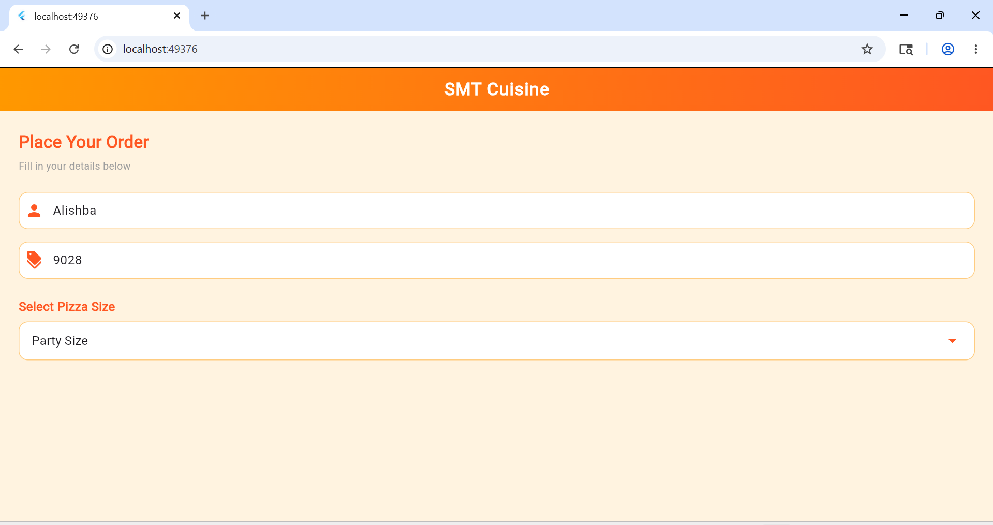

Task 4:
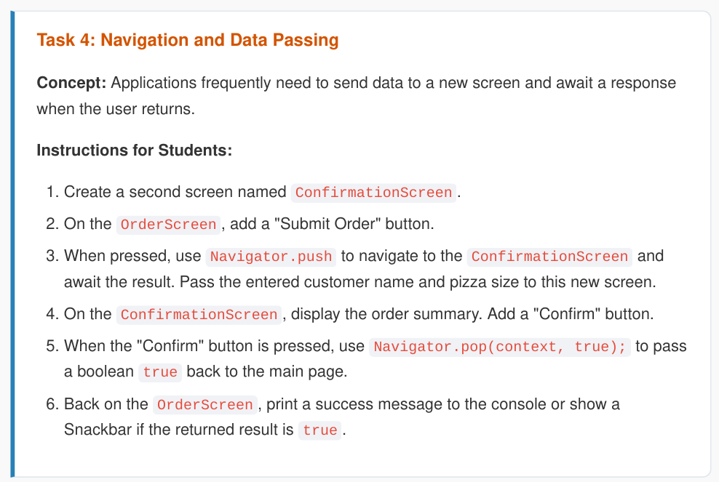

Code:
import 'package:flutter/material.dart';

void main() {
runApp(const MyApp());
}

class MyApp extends StatelessWidget {
const MyApp({super.key});

@override
Widget build(BuildContext context) {
return MaterialApp(
debugShowCheckedModeBanner: false,
home: const OrderScreen(),
);
}
}

class OrderScreen extends StatefulWidget {
const OrderScreen({super.key});

@override
State<OrderScreen> createState() => _OrderScreenState();
}

class _OrderScreenState extends State<OrderScreen> {
String? _discountError;
String _selectedSize = 'Medium';
String _customerName = '';

final List<String> _pizzaSizes = ['Small', 'Medium', 'Large', 'Party Size'];

void _submitOrder() async {
final result = await Navigator.push(
context,
MaterialPageRoute(
builder: (context) => ConfirmationScreen(
customerName: _customerName.isEmpty ? 'Guest' : _customerName,
pizzaSize: _selectedSize,
),
),
);

if (result == true && mounted) {
debugPrint('Order confirmed!');
ScaffoldMessenger.of(context).showSnackBar(
const SnackBar(
content: Text('Order confirmed! Thank you!'),
backgroundColor: Colors.green,
duration: Duration(seconds: 2),
),
);
}
}

@override
Widget build(BuildContext context) {
return Scaffold(
backgroundColor: Colors.orange.shade50,
appBar: AppBar(
flexibleSpace: Container(
decoration: const BoxDecoration(
gradient: LinearGradient(
colors: [Colors.orange, Colors.deepOrange],
),
),
),
centerTitle: true,
title: const Text(
'SMT Cuisine',
style: TextStyle(
color: Colors.white,
fontWeight: FontWeight.bold,
fontSize: 22,
letterSpacing: 1.2,
),
),
),
body: Padding(
padding: const EdgeInsets.all(24),
child: Column(
crossAxisAlignment: CrossAxisAlignment.start,
children: [
const Text(
'Place Your Order',
style: TextStyle(
fontSize: 22,
fontWeight: FontWeight.bold,
color: Colors.deepOrange,
),
),
const SizedBox(height: 6),
const Text(
'Fill in your details below',
style: TextStyle(fontSize: 13, color: Colors.grey),
),
const SizedBox(height: 24),
TextField(
onChanged: (value) => _customerName = value,
decoration: InputDecoration(
prefixIcon: const Icon(Icons.person, color: Colors.deepOrange),
hintText: 'Enter customer name',
hintStyle: const TextStyle(color: Colors.grey),
filled: true,
fillColor: Colors.white,
border: OutlineInputBorder(
borderRadius: BorderRadius.circular(12),
borderSide: BorderSide.none,
),
enabledBorder: OutlineInputBorder(
borderRadius: BorderRadius.circular(12),
borderSide: BorderSide(color: Colors.orange.shade200),
),
focusedBorder: OutlineInputBorder(
borderRadius: BorderRadius.circular(12),
borderSide: const BorderSide(
color: Colors.deepOrange,
width: 2,
),
),
),
),
const SizedBox(height: 16),
TextFormField(
decoration: InputDecoration(
prefixIcon: const Icon(Icons.discount, color: Colors.deepOrange),
hintText: 'Enter discount code',
hintStyle: const TextStyle(color: Colors.grey),
errorText: _discountError,
filled: true,
fillColor: Colors.white,
border: OutlineInputBorder(
borderRadius: BorderRadius.circular(12),
borderSide: BorderSide.none,
),
enabledBorder: OutlineInputBorder(
borderRadius: BorderRadius.circular(12),
borderSide: BorderSide(color: Colors.orange.shade200),
),
focusedBorder: OutlineInputBorder(
borderRadius: BorderRadius.circular(12),
borderSide: const BorderSide(
color: Colors.deepOrange,
width: 2,
),
),
),
onChanged: (value) {
setState(() {
if (value.contains(' ')) {
_discountError = "Don't use blank spaces";
} else {
_discountError = null;
}
});
},
),
const SizedBox(height: 24),
const Text(
'Select Pizza Size',
style: TextStyle(
fontSize: 16,
fontWeight: FontWeight.bold,
color: Colors.deepOrange,
),
),
const SizedBox(height: 8),
Container(
padding: const EdgeInsets.symmetric(horizontal: 16),
decoration: BoxDecoration(
color: Colors.white,
borderRadius: BorderRadius.circular(12),
border: Border.all(color: Colors.orange.shade200),
),
child: DropdownButton<String>(
value: _selectedSize,
isExpanded: true,
underline: const SizedBox(),
icon: const Icon(Icons.arrow_drop_down, color: Colors.deepOrange),
items: _pizzaSizes.map((size) {
return DropdownMenuItem<String>(
value: size,
child: Text(size),
);
}).toList(),
onChanged: (value) {
setState(() {
_selectedSize = value!;
});
},
),
),
const SizedBox(height: 32),
SizedBox(
width: double.infinity,
child: ElevatedButton(
onPressed: _submitOrder,
style: ElevatedButton.styleFrom(
backgroundColor: Colors.deepOrange,
padding: const EdgeInsets.symmetric(vertical: 16),
shape: RoundedRectangleBorder(
borderRadius: BorderRadius.circular(12),
),
),
child: const Text(
'Submit Order',
style: TextStyle(fontSize: 16, color: Colors.white),
),
),
),
],
),
),
);
}
}

class ConfirmationScreen extends StatelessWidget {
final String customerName;
final String pizzaSize;

const ConfirmationScreen({
super.key,
required this.customerName,
required this.pizzaSize,
});

@override
Widget build(BuildContext context) {
return Scaffold(
backgroundColor: Colors.orange.shade50,
appBar: AppBar(
flexibleSpace: Container(
decoration: const BoxDecoration(
gradient: LinearGradient(
colors: [Colors.orange, Colors.deepOrange],
),
),
),
centerTitle: true,
title: const Text(
'Confirm Order',
style: TextStyle(
color: Colors.white,
fontWeight: FontWeight.bold,
fontSize: 22,
),
),
),
body: Padding(
padding: const EdgeInsets.all(24),
child: Column(
crossAxisAlignment: CrossAxisAlignment.start,
children: [
const Text(
'Order Summary',
style: TextStyle(
fontSize: 22,
fontWeight: FontWeight.bold,
color: Colors.deepOrange,
),
),
const SizedBox(height: 24),
Container(
width: double.infinity,
padding: const EdgeInsets.all(20),
decoration: BoxDecoration(
color: Colors.white,
borderRadius: BorderRadius.circular(12),
border: Border.all(color: Colors.orange.shade200),
),
child: Column(
crossAxisAlignment: CrossAxisAlignment.start,
children: [
Row(
children: [
const Icon(Icons.person, color: Colors.deepOrange),
const SizedBox(width: 10),
Text(
'Customer: $customerName',
style: const TextStyle(fontSize: 16),
),
],
),
const SizedBox(height: 12),
Row(
children: [
const Icon(Icons.local_pizza, color: Colors.deepOrange),
const SizedBox(width: 10),
Text(
'Pizza Size: $pizzaSize',
style: const TextStyle(fontSize: 16),
),
],
),
],
),
),
const SizedBox(height: 32),
SizedBox(
width: double.infinity,
child: ElevatedButton(
onPressed: () => Navigator.pop(context, true),
style: ElevatedButton.styleFrom(
backgroundColor: Colors.deepOrange,
padding: const EdgeInsets.symmetric(vertical: 16),
shape: RoundedRectangleBorder(
borderRadius: BorderRadius.circular(12),
),
),
child: const Text(
'Confirm Order',
style: TextStyle(fontSize: 16, color: Colors.white),
),
),
),
],
),
),
);
}
}

Output:
